MANUSCRIPT CONSERVATION
Preserving Knowledge Written by Hand
For centuries, knowledge has been recorded and preserved through handwritten manuscripts. Today, many of these manuscripts have survived physically, but age, environmental conditions and the passage of time have made them increasingly fragile.
ASSF works to conserve, document and digitally preserve manuscript collections, with a particular focus on palm-leaf and handwritten paper manuscripts.

Jain Manuscripts: A Living Record of Knowledge
Jain manuscript traditions preserve centuries of written knowledge passed down through generations. Collectively associated with Jinvani, these collections contain far more than religious texts.
Alongside scriptures, philosophical works and commentaries, Jain manuscript collections include writings relating to:
Philosophy & Spiritual Thought
Mathematics & Numeracy
Astronomy & Cosmology
Medicine & Health
Literature & Language
History, Art & Illustrated Traditions
Many manuscripts are handwritten on palm leaf or handmade paper, while some collections also contain richly illustrated manuscripts and other historical records.
These manuscripts are therefore not only objects of religious heritage. They are material records of an intellectual and cultural tradition that has evolved across centuries.
[ IMAGE / VISUAL PLACEHOLDER ]

The Manuscripts We Conserve

Palm-Leaf Manuscripts
Palm-leaf manuscripts are among the oldest forms of written material preserved in the collections we work with. Text is inscribed onto prepared palm leaves, which are then assembled into manuscript units.
Over time, palm leaves can become brittle and develop cracks, splits, surface deterioration and other forms of physical damage. Insect activity and unsuitable storage conditions can further accelerate deterioration.
Because palm leaf is an organic material, its conservation requires methods suited to its physical characteristics and condition.
Palm-leaf manuscript: preferably ASSF field photograph

Handwritten Paper Manuscripts
Many of the collections we work with also contain manuscripts written by hand on handmade paper.
These manuscripts may develop brittleness, tears, folds, losses, staining, insect damage and deterioration of the writing medium over time.
The condition of paper can vary considerably from one manuscript to another—and sometimes from one folio to the next. Conservation therefore begins with a careful assessment of the material and its condition.
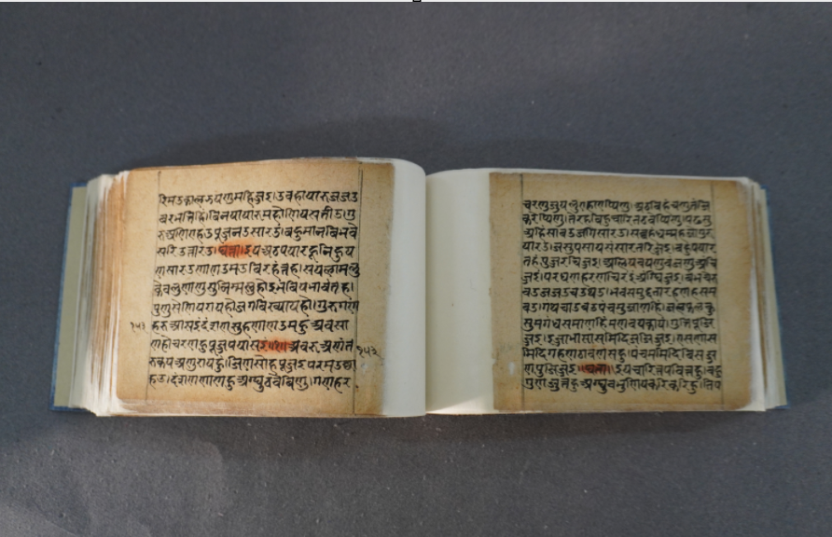
Handwritten paper manuscript / conservation detail

From Preservation to Deterioration

Manuscripts That Survived for Centuries Are Now Increasingly Fragile
The survival of these manuscripts over generations has depended on continued care and storage. However, the passage of time, repeated handling and environmental conditions can gradually weaken the materials.
Palm leaf can become brittle, cracked, split or damaged by insects. Handmade paper can develop brittleness, tears, folds, losses, staining and deterioration of the writing surface.
In many traditional repositories, manuscripts have historically been kept in storage conditions that were not designed for long-term archival preservation. Fluctuations in temperature and humidity, dust, inadequate ventilation, biological activity, unsuitable storage materials and limited collection-care infrastructure can accelerate deterioration.
The damage is not always immediately visible. By the time a manuscript becomes visibly fragile, deterioration may already have progressed significantly.
[ 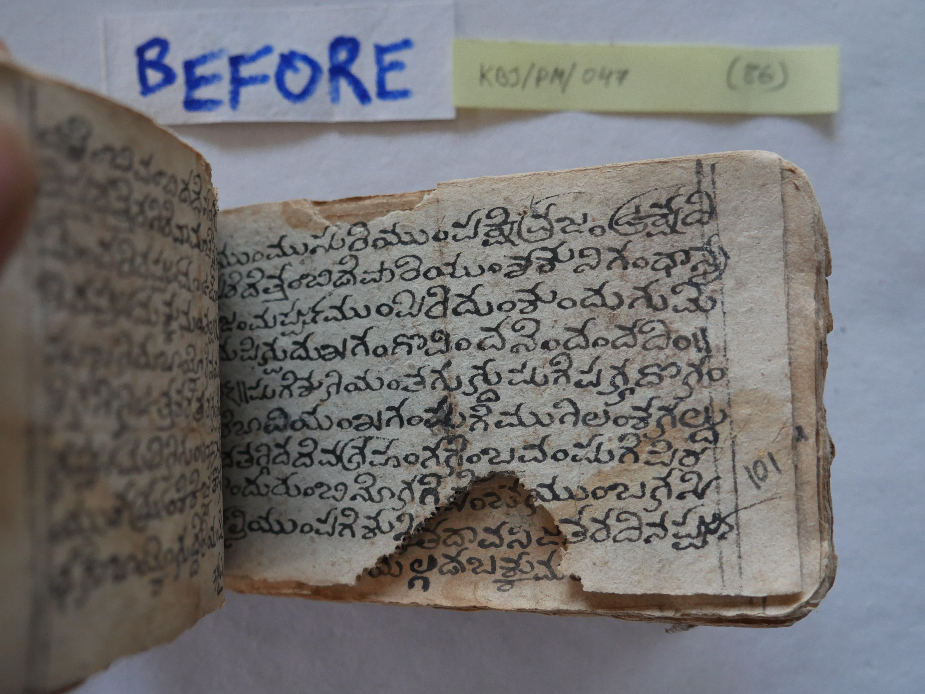

Why Conservation Becomes Necessary
A manuscript that has survived for hundreds of years can be lost within a much shorter period if deterioration is allowed to continue unchecked.
The objective of conservation is therefore not simply to make an old manuscript look better. It is to:
- Stabilise the physical material
- Prevent further deterioration
- Retain the original manuscript and its information
- Document its condition and treatment
- Create a durable digital record
- Enable safer future access and research

From Assessment to Conservation

Every Manuscript Begins With an Assessment
No two manuscript collections are exactly alike. Even within the same collection, individual manuscripts—and sometimes individual folios—can vary significantly in material, structure and condition.
Before treatment begins, our conservation team examines the manuscript to understand its material, physical condition, extent and nature of deterioration, and specific conservation requirements.
Based on this assessment, the team determines the appropriate treatment approach:

Preventive Conservation
When the manuscript is sufficiently stable and the priority is to prevent or slow further deterioration.

Curative Conservation
When deterioration has already affected the manuscript and active intervention is required to stabilise, repair or strengthen it.
The treatment approach is determined through condition assessment and adapted to the material and specific requirements of each manuscript.

Preventive Conservation

Protecting Manuscripts Before Extensive Intervention Is Required
Preventive conservation focuses on reducing the factors that can cause or accelerate deterioration.
- Safe handling and movement
- Appropriate storage
- Protective archival enclosures
- Environmental management
- Pest monitoring and management
- Preventive cleaning and collection care
- Regular condition monitoring
The objective is to slow deterioration, minimise future damage and reduce the need for extensive intervention.

Curative Conservation

When a Manuscript Requires Active Intervention
A significant proportion of the manuscript collections encountered by ASSF require curative conservation, as deterioration has already affected the physical stability of the material.
Curative conservation involves carefully planned interventions to stabilise, repair and strengthen deteriorated material while retaining the original manuscript and its information as far as possible.
The treatment is not applied mechanically across an entire collection. The conservation team assesses the material and adapts the intervention to the specific requirements of the manuscript and, where necessary, individual folios.

Our Curative Conservation Process

01 — Documentation & Condition Assessment
Recording the manuscript and assessing its material, structure, condition and areas requiring treatment.

02 — Preparation & Preliminary Treatment
Preparing the manuscript for conservation and carrying out any preliminary measures required for safe treatment.

03 — Surface Cleaning, Where Appropriate
Carefully addressing accumulated surface dirt and other removable contaminants using methods appropriate to the material and its condition.

04 — Condition-Specific Treatment
Applying the appropriate conservation treatment based on the nature and extent of deterioration.

05 — Repair & Strengthening
Stabilising and repairing cracks, tears, breaks, losses or other structural weaknesses where required.

06 — Stabilisation
Ensuring that the treated material is sufficiently stable for safe handling and long-term preservation.

07 — Protective Enclosure
Providing suitable protection for the conserved manuscript during storage and future handling.

08 — Digitisation
Creating a high-resolution digital record of the conserved manuscript and its contents.
The sequence and treatment methods may be adapted according to the material, condition and specific requirements of each manuscript and, where necessary, individual folios.

Documentation

Every Conservation Project Creates a Permanent Record
Conservation is not only about physically treating a manuscript. It also creates a documented record of what was found and what was done.
Manuscript Identification — Recording available identifying information and collection details.
Physical Description — Recording material, structure, format and other physical characteristics.
Folio Documentation — Recording folio counts and relevant folio-level observations.
Condition Assessment — Documenting deterioration and conservation requirements.
Treatment Documentation — Recording the intervention carried out during conservation.
Before-and-After Records — Creating visual documentation of the conservation process and outcome.
This documentation becomes an important part of the manuscript's long-term preservation record.

Digitisation

Conservation Protects the Original. Digitisation Protects Access.
Physical conservation protects the manuscript as an object. Digitisation creates a high-resolution digital record of its contents.
For fragile manuscripts, this is particularly important because digital access can reduce the need to repeatedly handle the original.

Digital Preservation

Creating the Record Is Only the Beginning
A digital image is useful only if it can be reliably preserved and retrieved in the future.
ASSF therefore looks beyond the act of scanning or photographing a manuscript.
Digital preservation involves maintaining:
- High-resolution image files
- Associated metadata
- Organised digital records
- Secure storage
- Backup copies
- Long-term accessibility
Our objective is to create a reliable digital record that can support future scholarship, documentation, research and access.

Building Conservation Capacity

Preservation That Can Continue
Long-term manuscript preservation requires knowledge beyond a single conservation project.
ASSF works to build local capacity in:
- Safe manuscript handling
- Preventive conservation
- Basic condition assessment
- Storage and collection care
- Identification of deterioration
- Monitoring and routine maintenance
Building local skills helps institutions continue caring for their collections after specialised conservation work is completed.

